NAME: KASIM ADEWALE SOLIU

        ID: KAS20505831

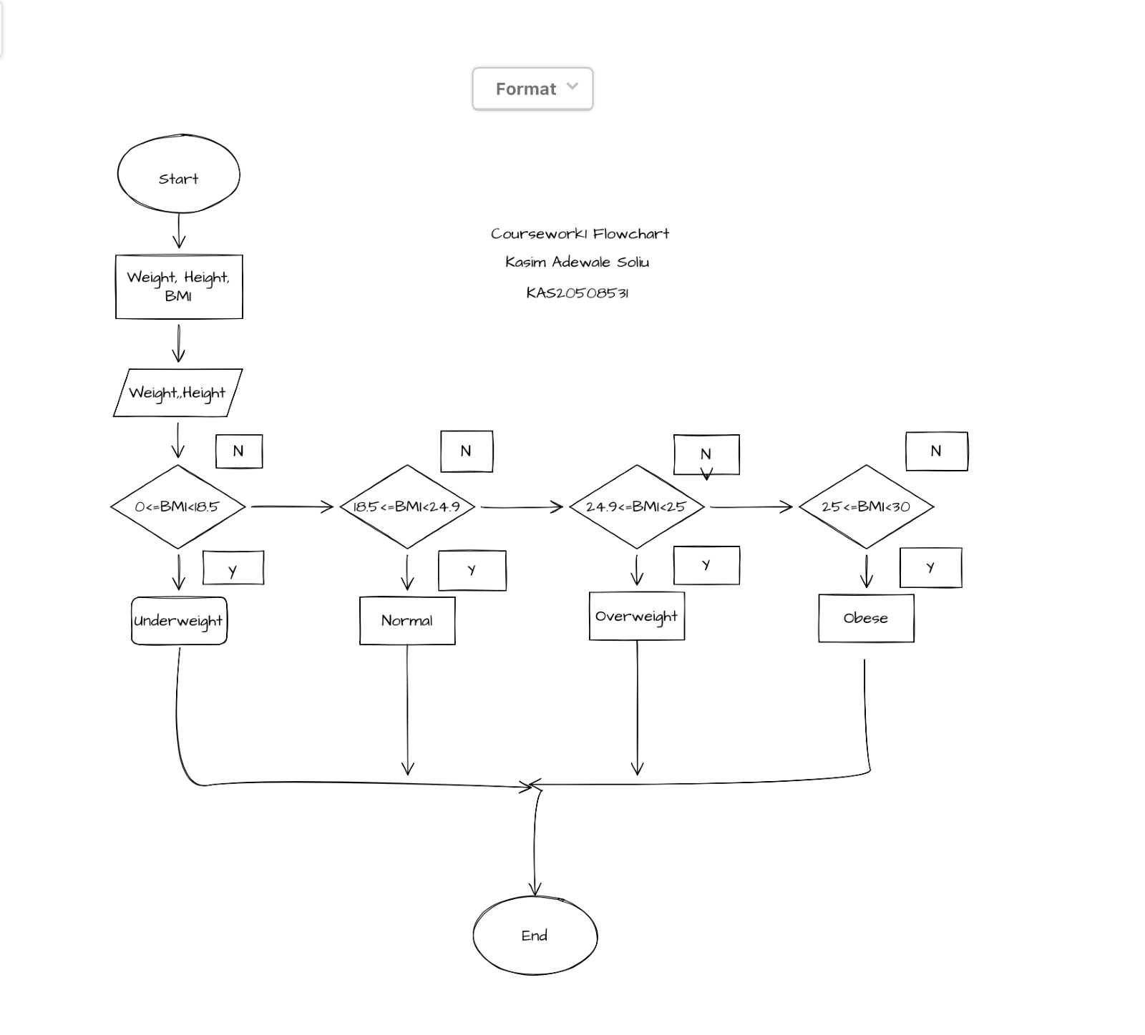

This is the way I decompose the problem, is by writing in the formula on how to solve the BMI (Body Mass Index) and the reason why is that the computer will be able to understand the process of the programme because you cannot just ask the computer to calculate the body mass index of a person you will need to program it to do so.

The flowchart was not really helpful because I started with the writing of the programme first, but the flowchart was not that difficult to do, and I know nothing about the pseudocode

The difficulties I met were that I cannot find a way to join the Metric BMI and the Imperial BMI so I had to separate the calculation of the metric bmi and the imperial bmi to write the programme

And the most difficult part in this coursework is the flowchart and how I tackled it is by going through the examples given to us, so it made me have an idea on how to draw the flowchart

What I learnt from this coursework is that programme can be written in many different uncomplicated ways for the user to understand

My favourite part in this coursework is the beginning of the programme where I was writing the formula into the programme because it makes the programme more easier and faster